**Exercises Week 2 -**

**Problem A**

Write a program that displays the dimensions of a letter-size (8.5 × 11 inches) sheet of paper in millimeters. There are 25.4 millimeters per inch. Use constants and comments in your program.

***The output:***

Letter size paper is 215.89999999999998 mm by 279.4 mm.

Paste your source code below:

width_in_inch = 8.5

length_in_inch = 11.0

mm_per_inch = 25.4

width_in_mm = width_in_inch * mm_per_inch

length_in_mm = length_in_inch * mm_per_inch

*print*("Letter size paper is", width_in_mm, "mm by", length_in_mm, "mm.")

Paste the Screenshot of your output below:



**Problem B:**

Write a program that computes and displays the perimeter of a letter-size (8.5 × 11 inch) sheet of paper and the length of its diagonal.

***The output:***

The perimeter is 39.0 inches.

The length of the diagonal is 13.901438774457844 inches.

Paste your source code below:

from math import sqrt

width = 8.5

length = 11.0

perimeter = (width + length) * 2

diagnonal = sqrt(width ** 2 + length ** 2)

*print*("The perimeter is", perimeter, "inches.")

*print*("The length of the diagonal is", diagnonal, "inches.")

Paste the Screenshot of your output below:

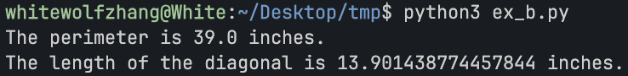

**Problem C:**

Write a program that finds and displays the square, cube, and fourth power of the number 6.

Use the ** operator only for the fourth power.

***The output:***

6 squared is 36

6 cubed is 216

6 to the fourth power is 1296

Paste your source code below:

number = 6

number_squared = number ** 2

number_cubed = number ** 3

number_fourth_power = number ** 4

*print*(number, "squared is", number_squared)

*print*(number, "cubed is", number_cubed)

*print*(number, "to the fourth power is", number_fourth_power)

Paste the Screenshot of your output below:

